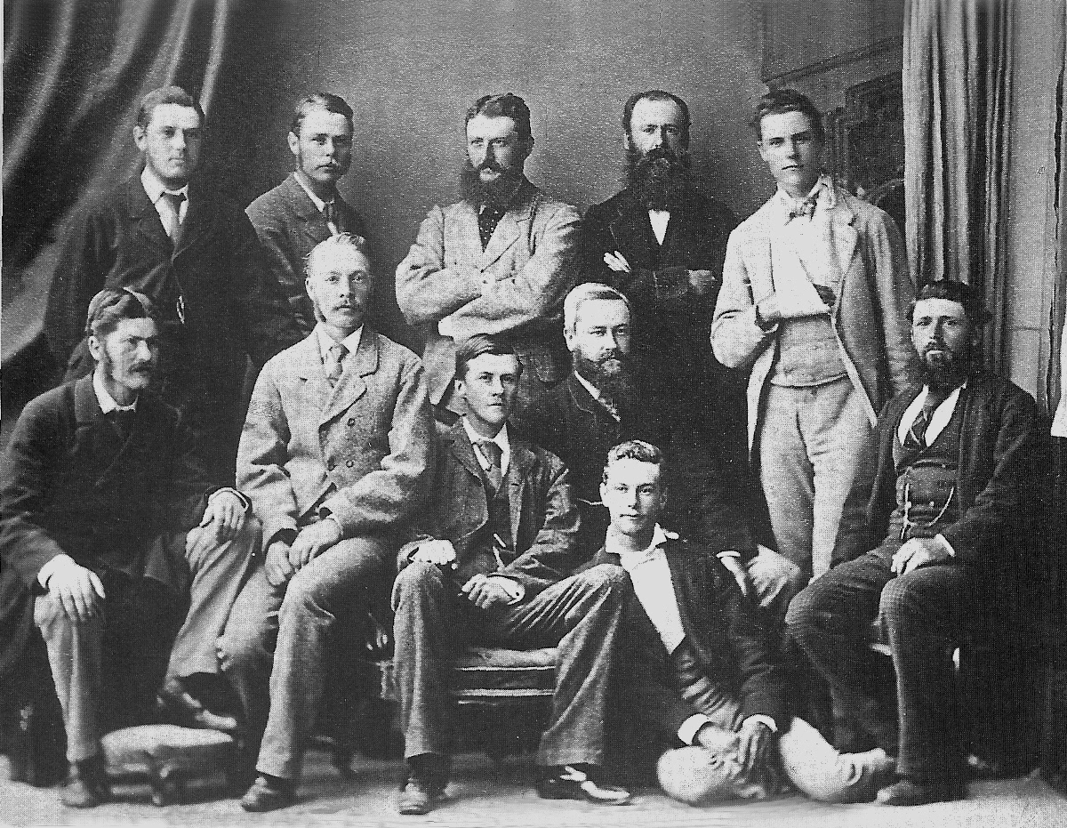

**Canterbury v Auckland 28 December 1877 Auckland Domain**

**Canterbury 93 & 163. Auckland 135 & 13. Canterbury won by 108 runs.**

**The Auckland second innings of 13 runs is the lowest score ever made against Canterbury**

**Back row:** **WV Milton, MJ Godby, A Perry, E Fowler, C Frith**

**Front row: WE Morrison, D Ashby, WF Neilsen (captain), AC Wilson, W Frith, J Wood**

